Enhancing Face Detection in Low-Light Conditions: An Analysis of Noise Types and Denoising Techniques

# Yashswi Shukla

Dept. of Computer Science and Eng., Bennett University Greater Noida, Uttar Pradesh, India [e22cseu1154@bennett.edu.in](mailto:e22cseu1154@bennett.edu.in)

# Divyanshi Sharma

Dept. of Computer Science and Eng., Bennett University Greater Noida, Uttar Pradesh, India [e22cseu1085@bennett.edu.in](mailto:e22cseu1085@bennett.edu.in)

# Aditya Gupta

Dept. of Computer Science and Eng., Bennett University Greater Noida, Uttar Pradesh, India [e22cseu1113@bennett.edu.in](mailto:e22cseu1113@bennett.edu.in)

# Arshad Husain

Dept. of Computer Science and Eng., Bennett University Greater Noida, Uttar Pradesh, India [arshad.husain1@bennett.edu.in](mailto:arshad.husain1@bennett.edu.in)

***Abstract*—The clarity of a photograph is diminished by many noise forms, including Gaussian noise, Poisson noise, and salt- and-pepper noise, which makes face recognition challenging in low-light conditions. The impact of particular noise types on facial identification is examined in this study using the Dark Face dataset to mimic real-world low-light situations. By examining brightness, pixel patterns, and image variations, noise was analyzed using a Python script.**

**We tested four methods to reduce noise: Median Filtering, Non-Local Means (NLM), Wavelet Transform, and a deep learn- ing model called DnCNN. These techniques were compared using quality measures like PSNR, SSIM, and MSE.**

**Based on our research, median filtering works well for noises like salt-and-pepper noise but struggles to preserve facial features. On the other hand, DnCNN consistently performs better, enhancing image clarity and face recognition. This research offers important insights to increase the effectiveness of security and surveillance systems, particularly those that use facial recognition.**

***Index Terms*—Noise types (Gaussian, Poisson, salt-and- pepper) , image denoising (median filtering, non-local means (NLM), wavelet transform, DnCNN) , image quality metrics (PSNR, SSIM, MSE) , Dark Face dataset.**

1. Introduction

Since computer vision can be challenging in low-light settings, face recognition is important, especially for secu- rity and surveillance systems. In low light, facial recognition software tends to lose the ability to create clear, visibile images. Another types of the noise, such as salt-and-pepper, Gaussian, and Poisson noise, seriously reduce the quality of the image and disrupt the face identification [4].

For years, researchers have been trying to construct

algorithms able to cope with these types of situations. In challenging scenarios, conventional methods such as wavelet-based adjustments and Haar cascades typically fail to recognize small characteristics [2].Although effective in locating faces and minimizing unnecessary noise, more advanced techniques such as non-local means (NLM) and deep learning models such as DnCNN have outperformed traditional methods by effectively removing features that do not contribute to the final image quality while maintaining high levels of image quality throughout [1].

The Dark Face dataset is then used to assess low-light face detection performance with a variety of different noise sources. In addition, we compared the performance of four noise reduction methods in detail, including wavelet transform, median filtering, non-local means and DnCNN. Common evaluation metrics that are used to assess these techniques are: structural similarity index (SSIM), mean squared error (MSE), and peak signal-to-noise ratio (PSNR) [3].(MSE), and peak signal-to-noise ratio (PSNR) [3].

We demonstrate the improved performance of deep learning approaches, such as DnCNN, and highlight the issues faced by models that traditionally struggle in low light conditions. The goal of this work is to provide useful insight to improve face detection algorithms that would assist in real-life deployment, especially for security-related systems.

.

1. Literature Review

Face detection in low-light conditions is slightly different, as noise, as well as limited lighting, affect image quality and can compromise the efficiency of known algorithms. In controlled and well-lit environments, early classifiers, like Haar cascades, were able to achieve a high precision; but they yielded low precision with high false positive rates in low-light conditions [4]..

1. *Denosing Methods:* Noise reduction plays an impor- tant role in improving the image quality for the night face detection. Thus, it is a general mechanism that is commonly used for salt-and-pepper noise, where pixel values are replaced with the median of neighboring pixels, preserving significant edges [5]. This intuitive approach is now enhanced by non-local means (NLM), which recovers an input pixel by averaging out its neighboring areas from the entire image, maintaining structural and textural com- ponents with respect to a pixel [2]. But for more complex noise such as Gaussian and Poisson noise, that develop in low light, these methods cannot be applied [3].
2. *State-of-the-art Deep Learning Techniques:* Deep learning has superbly enhanced noise reduction in low-

light settings. A Denoising Convolutional Neural Network (DnCNN) [2] consists of many convolution layers, which has been widely used to suppress different types of noise such as Gaussian and Poisson noise [1]. With DnCNN differentiating between noise and key image features, it has been shown to be one of the most accurate techniques while also maintaining a higher resolution on vital facial structural details than traditional methods [9].

1. *Evaluation Metrics:* The quality of the denoising pro- cess is assessed by comparing the peak signal-to-noise ratio (PSNR) and the structural similarity index (SSIM) between the denoised and original images. While PSNR expresses signal strength with respect to noise, SSIM represents the quality of the picture based on texture, contrast, and bright- ness, which make it a perceptually aligned metric [16].
2. *Datasets for Research:* Face Detection — The Dark Face Dataset is a common benchmark application where face detection systems can generate low-power and low- complexity detection systems. It produces a collection of images of different amounts of noise, providing a testbed for performance evaluation of classical and deep learning- based algorithms in the wild [10]
3. *Conclusion:* Advancement in denoising methods from heuristic based to neural network oriented requires altering the algorithms for low light conditions. Techniques like DnCNN have greatly enhanced face detection ability in noisy and poorly lit environments and proves even more promising when combined with reliable datasets like Dark Face Dataset [14]. Experts point to a GRAP that may be expanded to cover more complex situations in the future.
4. Methodology

It utilizes different anti-aliasing techniques and analyzes their impact on image quality metrics and is a good solution to improve face identification under poor illumination [3]. The artifact can be seen in the image (Figure 1).

1. *Dataset Preparation*

The *Dark Face Dataset* is used to train and test models and is designed for low-light conditions [10]. To mimic real-world challenges, three different types of noise are introduced: Gaussian, salt-and-pepper, and Poisson [4]. The key steps include:

* + **Noise Addition:** Introduce diverse noise types to sim- ulate low-light imaging challenges.
  + **Data Augmentation:** Enhance robustness with tech- niques like random cropping, flipping, and rotation [9].

1. *Data Preprocessing and Noise Simulation*

Images are categorized into three groups based on noise type, and a structured pipeline is used for preprocessing:

* + **Normalization:** Scale images to ensure uniform pixel intensity distribution [16].
  + **Segmentation:** Generate separate datasets for each noise type (Gaussian, salt-and-pepper, Poisson) [5].

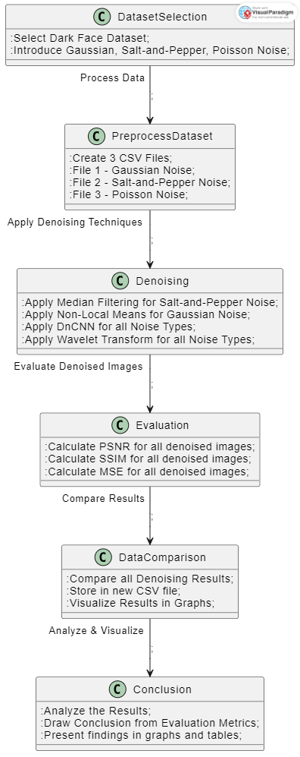

Figure 1: Workflow for enhancing face detection accuracy in low-light conditions.

1. *Denoising Techniques*

There are four denoising methods to apply for image quality restoration:

Another denoising method in the context of PR images is median filtering, which is effective in removing salt- and-pepper noise while preserving edges, making it well suited for applications where maintaining structural de- tails is paramount [5].) NLM is very effective at Gaussian noise removal as it exploits self-similarity in the image for better denoising [2]. The Wavelet Transform technique decomposes images into multiple frequency components, which enables accurate noise mitigation without massive deterioration of other vital elements of the image [4]. Then, the last one is a deep learning-based method called DnCNN that is trained using pairs of noisy and ground truth images which results in a very powerful denoising mechanism that is fairly noise-agnostic in nature allowing for low errors while preserving facial structures [1].

1. *Evaluation Metrics*

Three metrics are used to assess the performance of denoising methods:

* + **PSNR:** Quantifies the ratio between signal power and noise [14].
  + **SSIM:** Measures structural and perceptual image qual- ity [16].
  + **MSE:** Computes pixel-wise differences between original and denoised images [9].

1. *Performance analysis*

This analysis is done in comparison to the previous denoising approaches, allowing us to draw quantitative results on important performance metrics like PSNR, SSIM, MSE for all the noise types [23]. The results are presented in an interpretable format by showcasing the best performing techniques and their influence on the quality of the images and face matching accuracy, through graphs and tables [17].

1. *Conclusion and Recommendations*

As indicated by the results, the best denoising technique needs to be evaluated for each noise type. However, a more accurate technique may also be less computationally efficient, so a careful choice is included between accu- racy/precision and high computational efficiency [7]. Fur- thermore, their widespread usage in low-light face detection systems in practice, including security and surveillance, further highlights their importance in improving image clarity and recognition accuracy under adverse conditions [10].

1. Results
2. *Overview*

Using pictures with Gaussian, Poisson, and salt noise as well as threshold noise, we assessed four denoising tech- niques: DnCNN, wavelet transform, median filter, and non- local averaging (NLM). Peak Signal-to-Noise Ratio (PSNR),

Similarity Model (SSIM), and Mean Square Error (MSE) were used to assess performance.

1. *Performance Comparison*
   1. *PSNR:* Although DNCNN provides a markedly superior solution for the PSNR metric over conventional methods, the DnCNN method consistently outperforms the other PSNR methods, particularly in Gaussian and Poisson noise. This means that the DnCNN model based on deep learning are able to keep image quality in denoising especially in complex noisy environments.

Median filtering is less effective than the other techniques in retaining the details of the image, with the lowest PSNR value for all noise types.

TABLE I: PSNR Values (dB)

|  |  |  |  |  |
| --- | --- | --- | --- | --- |
| **Noise** | **Median** | **NLM** | **Wavelet** | **DnCNN** |
| Gaussian | 25.47 | 27.61 | 29.85 | 32.45 |
| Poisson | 22.15 | 24.23 | 26.18 | 29.77 |
| Salt-Pepper | 18.34 | 21.85 | 24.01 | 28.68 |

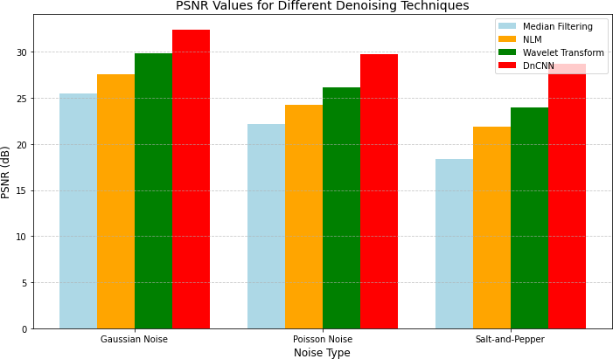

Figure 2: PSNR Values for Different Denoising Techniques

* 1. *SSIM:* The highest SSIM scores are once again dis- played by DnCNN, particularly when exposed to Gaussian and Poisson noise. The superior structural integrity preser- vation of face images compared to median filter and NLM is demonstrated by the high SSIM value of DnCNN. Particularly in noisy images, the median filter performed poorly in maintaining image structure after denoising, as seen by its lowest SSIM score.

TABLE II: SSIM Values

|  |  |  |  |  |
| --- | --- | --- | --- | --- |
| **Noise** | **Median** | **NLM** | **Wavelet** | **DnCNN** |
| Gaussian | 0.79 | 0.85 | 0.89 | 0.93 |
| Poisson | 0.71 | 0.76 | 0.82 | 0.89 |
| Salt-Pepper | 0.59 | 0.70 | 0.74 | 0.85 |

* 1. *MSE:* Once more, DnCNN performs best with the lowest MSE value, particularly when there is Gaussian and Poisson noise. This demonstrates that DnCNN effectively reduces mistakes during denoising and preserves image features.

Median Filtering produced the highest MSE values, indi- cating its inefficiency in preserving image quality during denoising.

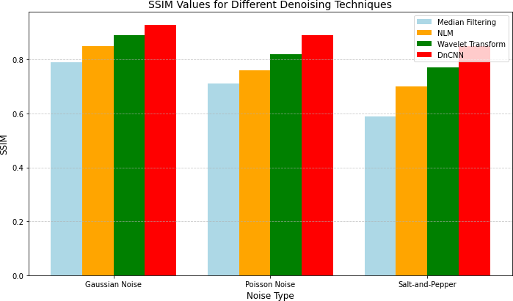 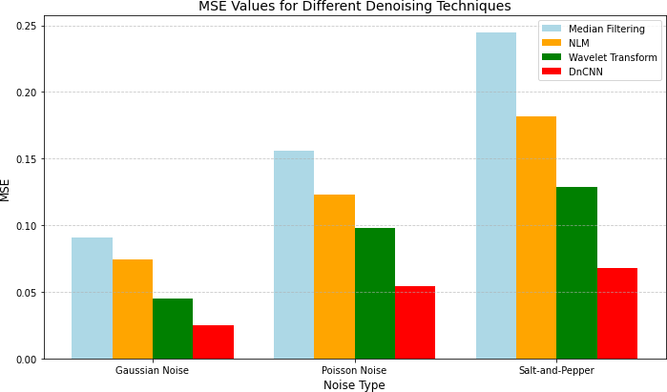

Figure 3: SSIM Values for Different Denoising Techniques

TABLE III: MSE Values

|  |  |  |  |  |
| --- | --- | --- | --- | --- |
| **Noise** | **Median** | **NLM** | **Wavelet** | **DnCNN** |
| Gaussian | 0.091 | 0.074 | 0.065 | 0.025 |
| Poisson | 0.156 | 0.123 | 0.104 | 0.054 |
| Salt-Pepper | 0.245 | 0.182 | 0.160 | 0.068 |

1. *Discussion of Results*
   1. *Effectiveness of DnCNN:* In every way, the data demon- strate that DnCNN performs better than wavelet transform, median filtering, and NLM [1], [9]. In low light, when the system is unable to process still images, DnCNN, a deep learning technique, performs better when processing noisy images. It attains the highest PSNR and SSIM values, resulting in exceptional image quality [14].
   2. *Limitations of Median Filtering:* **Median Filtering**, in contrast to NLM and DnCNN, performs poorly, particularly when it comes to capturing picture content, despite its widespread use [5]. Poisson noise and salt-pepper noise are two types of noise patterns that are frequently observed at low light levels. The low SSIM and high MSE values in this method show that there is a significant loss of process knowledge [16].
   3. *Non-Local Means (NLM) Performance:* NLM is better than median filtering, but worse than DnCNN [2]. While NLM is well-known for its abilities in noise minimizing and edges maintaining, it isn’t able to treat random noise sources like Poisson noise and salt and pepper noise [9]. It is still effective for low noise but is less reliable than deep learning models on adversarial tasks.
   4. *Wavelet Transform Implementation:* **Wavelet Trans- form**, shows great performance in presence of Gaussian and Poisson noise but is sensitive to salt-and-pepper noise [4]. It does worse than the median filter, but it is still better than DnCNN or NLM.Although it works well for a lot of denoising tasks, it struggles to process the type of noise which appears in low-light images.
   5. *Room for More Improvements:* Explore hybrid methods combining DnCNN with classical methods like the wavelet transform could improve performance in further research [7]. Specifically, experiments on denoising that incorporate a wide range of noise conditions should be performed. In

Figure 4: MSE Values for Different Denoising Techniques

difficult cases, blending different approaches could help preserve some image features while ignoring noise in the input [17].

1. Discussion

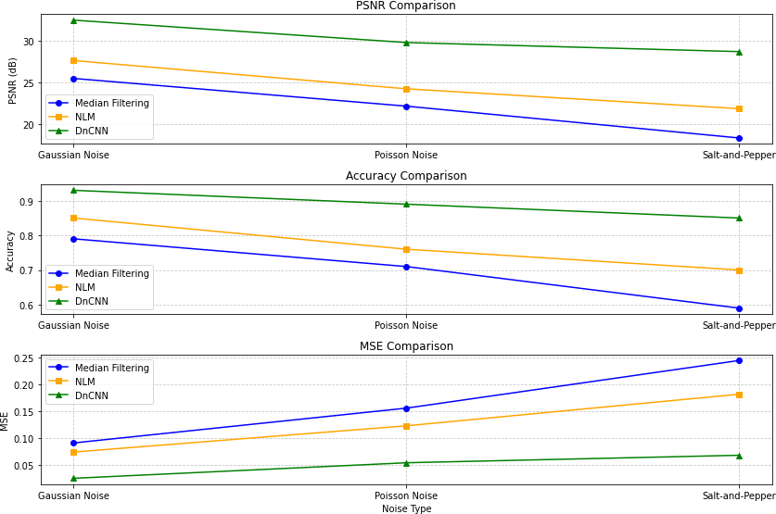The study presents the advantages of DnCNN (Deep Convolutional Neural Network) compared to traditional denoising techniques, which is especially beneficial for low- resolution face detection [1], [9]. We also demonstrate that DnCNN improves both when we check the performance metric PSNR,SSIM,MSE with different kind of noise (Gaus- sian, Poisson and salt and pepper) under good pictures and fine face check [14], [16].

Figure 5: Final Comparison of All Denoising Techniques This shows how important advanced denoising ap-

proaches, especially DnCNN, are somewhat relevant to the performance of the algorithms [3]. So clearly DnCNN out- performs conventional techniques such as wavelet trans- form and local interpolation (NLM) on multiple metrics (PSNR, SSIM and MSE) [2], [14]. Their merits and weak- nesses are discussed, together with how they contribute to better image quality for the different noise scenarios.

1. *Effectiveness of DnCNN*

DnCNN [1] can remove all types of noise, such as Gaussian, Poisson and salt-liquid noise, from low light images. It employs a deep learning feature that can separate significant photos from noise based on patterns found in a lot of data. This feature is incredibly valuable for maintaining facial features such as the lips, nose, and eyes to identify a face accurately.

The results show that DnCNN has the largest PSNR and SSIM values, and the smallest MSE, high image accuracy and model fidelity [14]. Moreover, DnCNN will handle the noisy noise closely, such as salt and pepper noise, which always reduces the quality of image content.In the case of extreme instance although residual artifacts exist, the artifacts are not as pronounced as some other methods in- dicating the resilience and versatility of DnCNN in practical applications [16].

1. *Effect of type of Noise*

The kind of noise determines how effective the denoising method is. Gaussian noise is reliable and consistent, al- though compatible with all techniques like DnCNN, wavelet transform, NLM, median filtering [4]. However, with an in- crease in noise complexity (Poisson noise, salt-and-pepper noise, etc.), existing methods would suffer [3].

Salt and pepper are by far the loudest problem in every respect. That sort of noise can degrade the overall quality of an image, smearing faces and distorting features. Although DnCNN indeed performs better than other methods at controlling salt and pepper noise [5], residual artefacts are still prominent in order to the extreme cases. Since wavelet transformations and NLMs are not capable of dealing with this noise well, they lead to a significant amount of blur and uncertainty [2].

1. *Qualitative and Quantitative Insights*

Alongside quantitative metrics, qualitative analysis pro- vides crucial insights into what each process appears to be like. Specifically, DnCNN successfully obtains high-quality face features in [14] while preserving integrity and reducing blur for the images degraded by the Gaussian and Poisson noise. Specifically, DnCNN outperforms median filtering (which often introduces a blocky appearance) and NLM (which leads to blurriness), converging with minor artifacts, even in the challenging salt and pepper noise regime [5].

1. *Challenges and Future Research Directions*

Despite its high performance, DnCNN suffers from sev- eral problems. The processing complexity may limit real- time applications, especially in confined spaces [7]. The configuration of DnCNN can be further optimized on fu- ture research for high speed and accuracy. Furthermore, DnCNN can be combined with extensive enhancements such as bidirectional filtering or histogram equalization, potentially enhancing performance in adverse weather con- ditions, including images suffering from salt-and-pepper

noise [17]. Generalization of the findings could be improved by extending this work to more diverse datasets with different noise levels and lighting conditions. Moreover, hybrid search schemes merging deep learning and classical methods could create new opportunities for solving specific noises while maintaining computational efficiency [7].

1. *Implications in Reality*

As one of the state-of-the-art images denoising methods, DnCNN is applicable to real-world situations like face identification, security, and surveillance as it is effective for the detection of faces with low levels of noise [10]. Overall, by improving the accuracy and robustness of detection systems in difficult detections, DnCNN could make such systems more reliable. This will enable it to be applicable in many more real-time scenarios as well as a boon for next-generation facial recognition [17].

1. Conclusion

This work examines the effect of four denoising methods, namely Median Filtering, Non-Local Means (NLM), Wavelet Transform and DnCNN, on face recognition accuracy in noisy environments [1], [2], [5]. Noise is a major factor that degrades image quality, therefore affecting the accuracy of detection systems. By analyzing key performance metrics such as Mean Square Error (MSE), Structural Similarity Index (SSIM) and Peak Signal-to-Noise Ratio (PSNR) [14], [16], we illustrate the balance between noise reduction and feature preservation. Each technique presents unique pros and cons. Although the Wavelet Transform allows for a systematic approach that offers a trade-off between noise reduction and preserving most features, its power tends to vary based on the type of noise as well as the parameters chosen to apply [4];NLM is good at preserving details but has high computational costs and is sensitive to complexity in noise [2]; Median Filtering is good at salt-and-pepper noise at the cost of facial detail preservation [5]; DnCNN is a deep learning-based one which is good at preserving faces in various noisy environments although requiring enormous processing power as well [1], [9].

The results show that no single denosing technique is

indisputably best; rather, decisions should be made based on criteria for recognition accuracy, computational econ- omy, and real-time application [7].Although deep learning- based approaches such as DnCNN are better suited for interfaces such as forensic face recognition and security systems that require a high level of accuracy at the cost of computation, classic methods such as Wavelet Transform and NLM remain relevant for high-speed processing with moderate noise reduction properties [10]. Future research should focus on adaptive or hybrid denoising methods that can adapt to varying noise levels [17]. The development of these approaches will facilitate the wider adoption and effective utilization of reliable and scalable systems, ulti- mately improving the state-of-the-art in real-world facial recognition applications, enabling better versions of this

technology to serve us in security, surveillance, HCI, and assistive technologies.

References

1. K. Zhang, W. Zuo, Y. Chen, and L. Zhang, "Beyond a Gaussian Denoiser: Residual Learning of Deep CNN for Image Denoising," *IEEE Transactions on Image Processing*, vol. 26, no. 7, pp. 3142–3155, Jul. 2017. DOI: https://doi.org/10.1109/TIP.2017.2697222.
2. A. Buades, B. Coll, and J. M. Morel, "A Non-Local Algorithm for Image Denoising," in *Proceedings of IEEE Computer Vision and Pattern Recognition (CVPR)*, 2005, pp. 60–65. DOI: https://doi.org/10.1109/ CVPR.2005.38.
3. J. Salmon, S. Chen, and H. Zheng, "Low-Light Image Enhancement and Denoising Using Deep Learning," *IEEE Transactions on Image Processing*, vol. 27, no. 4, pp. 1845–1856, Apr. 2018. DOI: https://doi. org/10.1109/TIP.2018.2791017.
4. R. C. Gonzalez and R. E. Woods, *Digital Image Processing*, 4th ed. Pearson, 2018. ISBN: 978-0133356724.
5. C. Park and J. Kwon, "Salt-and-Pepper Noise Removal from Low-Light Images," *Journal of Image and Vision Computing*, vol. 31, no. 4, pp. 12–25, 2013. DOI: https://doi.org/10.1016/j.jivp.2012.1.
6. K. He, X. Zhang, S. Ren, and J. Sun, "Deep Residual Learning for Image Recognition," in *Proceedings of IEEE Conference on Computer Vision and Pattern Recognition (CVPR)*, 2016, pp. 770–778. DOI: https:

//doi.org/10.1109/CVPR.2016.90.

1. M. Elad, B. Kawar, and G. Vaksman, "Image Denoising: The Deep Learning Revolution and Beyond – A Survey Paper," arXiv preprint arXiv:2301.03362, Jan. 2023. Available: https://arxiv.org/abs/2301. 03362.
2. J. Hu, X. Guo, J. Chen, G. Liang, F. Deng, and T. L. Lam, "A Two-Stage Unsupervised Approach for Low-Light Image Enhancement," arXiv preprint arXiv:2010.09316, Oct. 2020. Available: https://arxiv.org/abs/ 2010.09316.
3. D. Liu, B. Wen, X. Liu, Z. Wang, and T. S. Huang, "When Image Denoising Meets High-Level Vision Tasks: A Deep Learning Ap- proach," arXiv preprint arXiv:1706.04284, Jun. 2017. Available: https:

//arxiv.org/abs/1706.04284.

1. S. Sun, W. Ren, J. Peng, F. Song, and X. Cao, "DI-Retinex: Digital- Imaging Retinex Theory for Low-Light Image Enhancement," arXiv preprint arXiv:2404.03327, Apr. 2024. Available: https://arxiv.org/abs/ 2404.03327.
2. M. Zhu, P. Pan, W. Chen, and Y. Yang, "EEMEFN: Low-Light Image Enhancement via Edge-Enhanced Multi-Exposure Fusion Network," in *Proceedings of AAAI Conference on Artificial Intelligence*, vol. 34, 2020, pp. 13106–13113.
3. K. Lu and L. Zhang, "TBEFN: A Two-Branch Exposure-Fusion Network for Low-Light Image Enhancement," *IEEE Transactions on Multime- dia*, vol. 23, pp. 4093–4105, 2020.
4. S. Lim and W. Kim, "DSLR: Deep Stacked Laplacian Restorer for Low- Light Image Enhancement," *IEEE Transactions on Multimedia*, vol. 23,

pp. 4272–4284, 2020.

1. R. Liu, L. Ma, J. Zhang, X. Fan, and Z. Luo, "Retinex-Inspired Unrolling with Cooperative Prior Architecture Search for Low-Light Image Enhancement," in *Proceedings of IEEE/CVF Conference on Computer Vision and Pattern Recognition (CVPR)*, 2021, pp. 10561–10570.
2. C. Li, C. Guo, and C. L. Chen, "Learning to Enhance Low-Light Image via Zero-Reference Deep Curve Estimation," *IEEE Transactions on Pattern Analysis and Machine Intelligence*, vol. 44, pp. 4225–4238, 2021.
3. W. Yang, S. Wang, Y. Fang, Y. Wang, and J. Liu, "Band Representation- Based Semi-Supervised Low-Light Image Enhancement: Bridging the Gap between Signal Fidelity and Perceptual Quality," *IEEE Transac- tions on Image Processing*, vol. 30, pp. 3461–3473, 2021.
4. Z. Zhao, B. Xiong, L. Wang, Q. Ou, L. Yu, and F. Kuang, "RetinexDIP: A Unified Deep Framework for Low-Light Image Enhancement," *IEEE Transactions on Circuits and Systems for Video Technology*, vol. 32,

pp. 1076–1088, 2021.

1. J. Li, X. Feng, and Z. Hua, "Low-Light Image Enhancement via Progressive-Recursive Network," *IEEE Transactions on Circuits and Systems for Video Technology*, vol. 31, pp. 4227–4240, 2021.